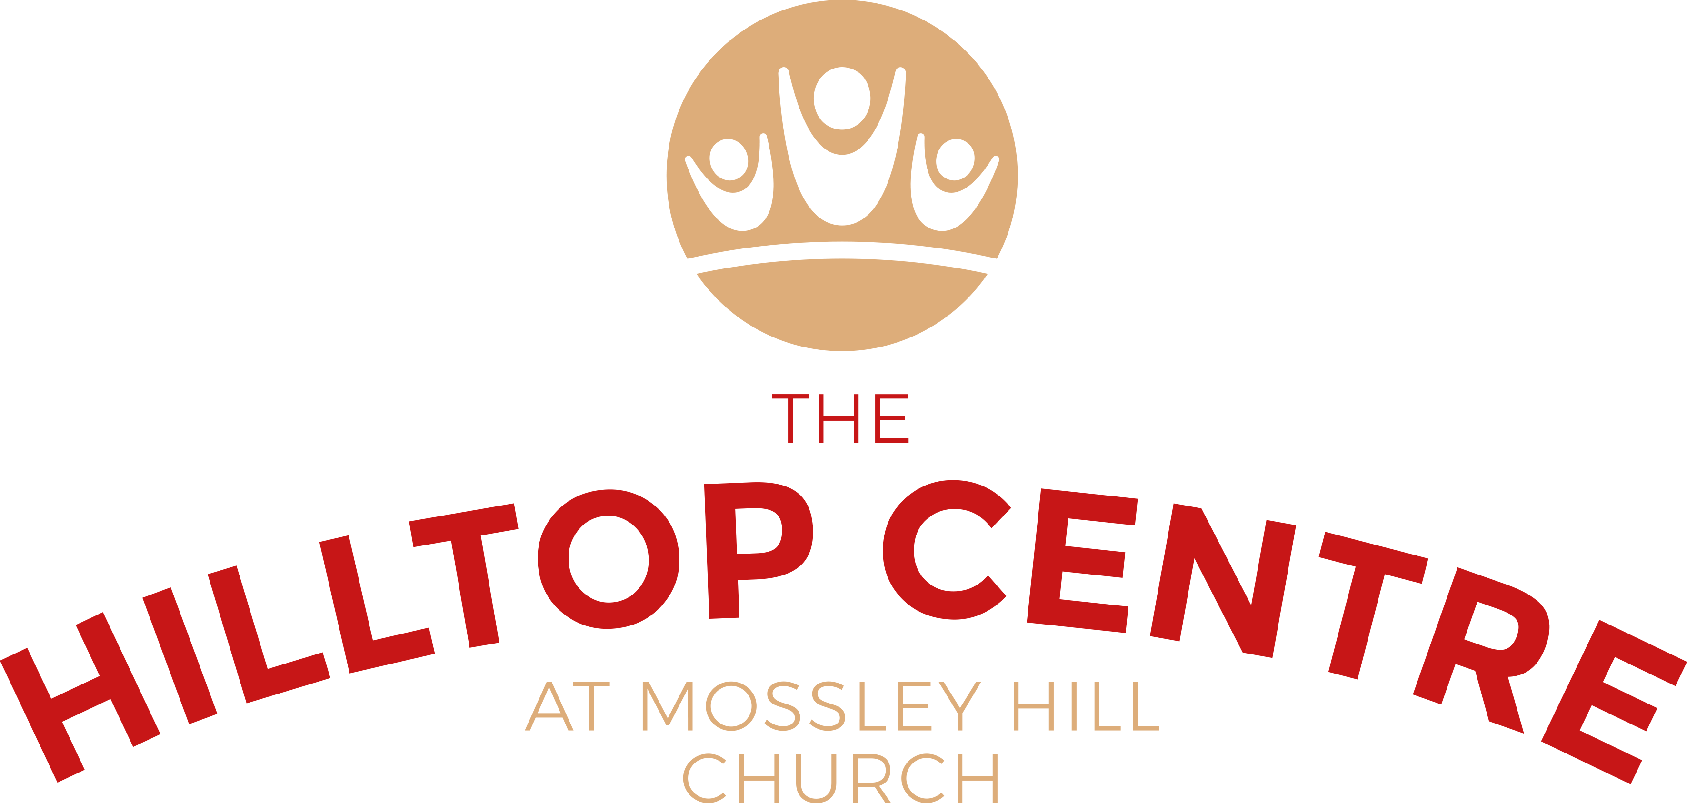

VENUE HIRE CHILDREN’S PARTY BOOKING

WEBSITE ENQUIRY FORM

Hirer Name

Phone ( mobile or landline)

Email Address

Address

Dates required

(please put alternatives if possible)

Please note that we can only accommodate Sundays 1-5pm

Number of guests

( max of 25 children)

Age of child/ children

PREMISES REQUIRED FOR HIRE

HILLTOP CENTRE HALL

CHURCH HALL KITCHEN

COFFEE BAR

OUTSIDE SPACE

WILL YOU BE BRINGING A BOUNCY CASTLE TO USE ON THE OUTSIDE LAWN SPACE?

Any other requirements:

CHARGES:

£100 for a 4 hour period using the Church hall and including kitchen, outside lawn space, tables and chairs

£30 For use of the Coffee bar ( including tables and chairs) when hired with the hall on the same booking.

£25 For use of own bouncy castle on the outside lawn space.

